**Steady Paced Assembled Coding Experience – S.P.A.C.E.**

**Project Proposal**

We want to set up an application where users can log in and learn about programming languages starting with programming fundamentals and C#. Users who are interested in learning a new language can use this application to learn the fundamentals and work their way up to a more advanced understanding of the selected language. Users are presented a challenge to understand the language and get heavy emphasis on each function, method, etc. that is included in the language. Users can track their progress by their logins and resume where they left off. By keeping track of their progress, users can show or indicate their level of understanding to other people.

1. User is looking to learn or expand their knowledge of a new programming language.
2. User can see the breakdown of coding logic resources.
3. User can register to track their progress with a username, password, and email. User can update or delete their account information.
4. User can pursue their chosen language or resume a previous session.
5. User can select their level of difficulty with a language.
6. User is presented with a table of contents of all the different chapters of topics and is initially started on chapter 1 (left side – TOC; right side - Chapter).
7. User is presented with the introduction of the topic contents.
8. User is a given a walkthrough of each topic with code examples.
9. User is given a comprehensive coding challenge.
10. User is presented an encompassing summary of the material with practical application examples
11. User has the option of adding comments about their chapter experience.
12. User has the option of exploring additional topics.

|  |  |  |  |  |  |
| --- | --- | --- | --- | --- | --- |
| USER_ID | UserName | Password | Email | Progress | COMMENT_ID |

|  |  |
| --- | --- |
| COMMENT_ID | COMMENT_DESCRIP |

|  |  |
| --- | --- |
| CHALLENGE_ID | CHALLENGE_DESCRIP |

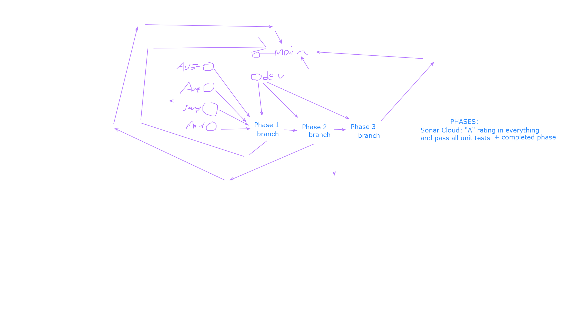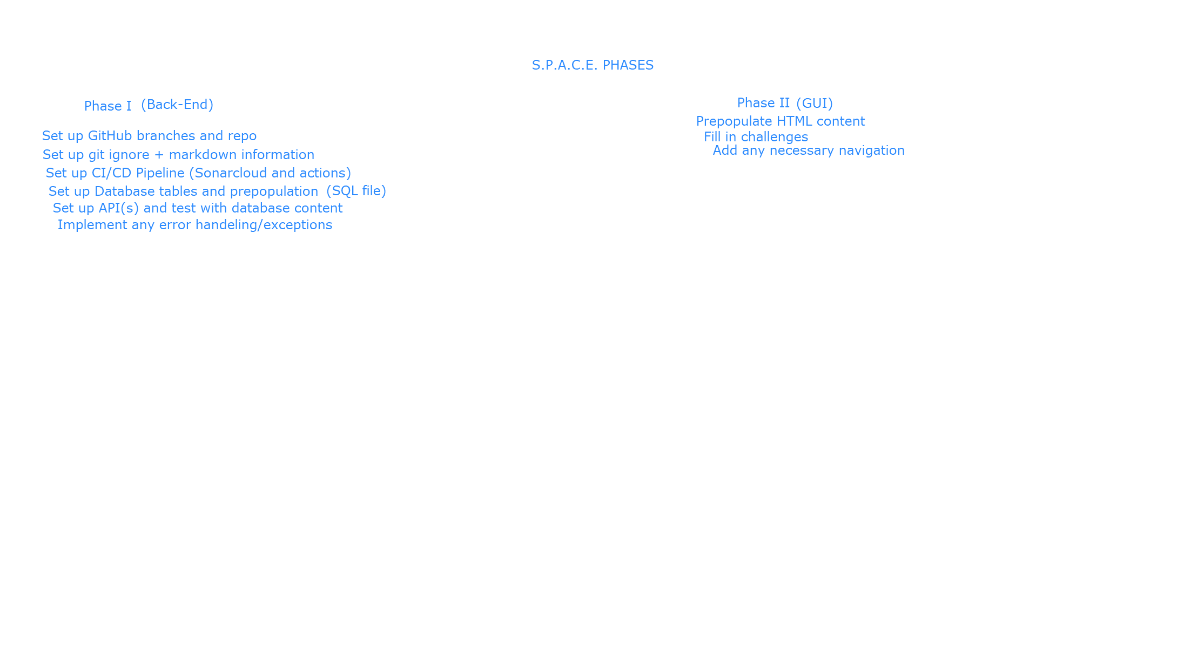

Phase III (Finishing Touches)

Making connections between Backend and Frontend

Push code to main

If MVP is met, go on to any stretch goals